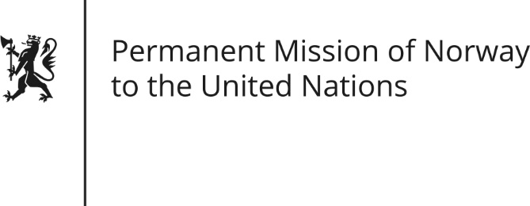

STATEMENT

Universal Periodic Review of Tanzania, 9 May 2016.

Norwegian statement by Andreas Gahr Brunsvig.

Check against delivery

Mr. President,
Norway welcomes the delegation from Tanzania and commends its efforts to implement recommendations from the last UPR-review. (Increased access to education, as well as efforts to improve public services delivery through combatting corruption and inefficiency, are particularly encouraging.)
Despite positive developments (such as the establishment of gender and children desks at major police stations and awareness raising programs), the number of reported instances of gender based violence and violence against children remains very high. Norway recommends stepping up efforts to end violence against women and children, and eliminate harmful traditional practices such as FGM and killing of women accused of witchcraft.
Further, Norway recommend that Tanzania implements the provisions in the African Union’s Maputo protocol into national legislation, including women’s rights to medical abortion in cases of sexual assault, rape, incest, and where the life of the mother or the fetus is in danger.
Norway also recommends enacting a non-discriminatory law on succession, inheritance and land-rights issues.
While noting positively that Tanzania has observed a moratorium on the death penalty for the past 20 years, Norway recommends ratifying the Second Optional Protocol to the ICCPR.
Norway further recommend that Tanzania combat impunity for crimes committed against sexual minorities, ensure that their right to Assembly and Association is upheld, and ensure the right to equal treatment in accessing health services and justice.
Finally, Norway recommends that Tanzania ratify ILO Convention No. 169.

Thank you.

